Job Interview

|  |  |  |
| --- | --- | --- |
| ÐÐ°ÑÑÐ¸Ð½ÐºÐ¸ Ð¿Ð¾ Ð·Ð°Ð¿ÑÐ¾ÑÑ job interview | ÐÐ°ÑÑÐ¸Ð½ÐºÐ¸ Ð¿Ð¾ Ð·Ð°Ð¿ÑÐ¾ÑÑ job interview | ÐÐ°ÑÑÐ¸Ð½ÐºÐ¸ Ð¿Ð¾ Ð·Ð°Ð¿ÑÐ¾ÑÑ job interview |

|  |  |  |
| --- | --- | --- |
| 1. Make sure you know the following words and word combinations: | | |
| To hire | To improve | Polite |
| To turn back | Stress | Silly |
| To respond | Anxiety | On one’s own |
| To stumble over | Conversation | Small talk |
| To leave out | A fear of failure | Tough |
| To think outside the box |  |  |

1. Choose the examples of a small talk. Which of them are likely to happen during the JI?

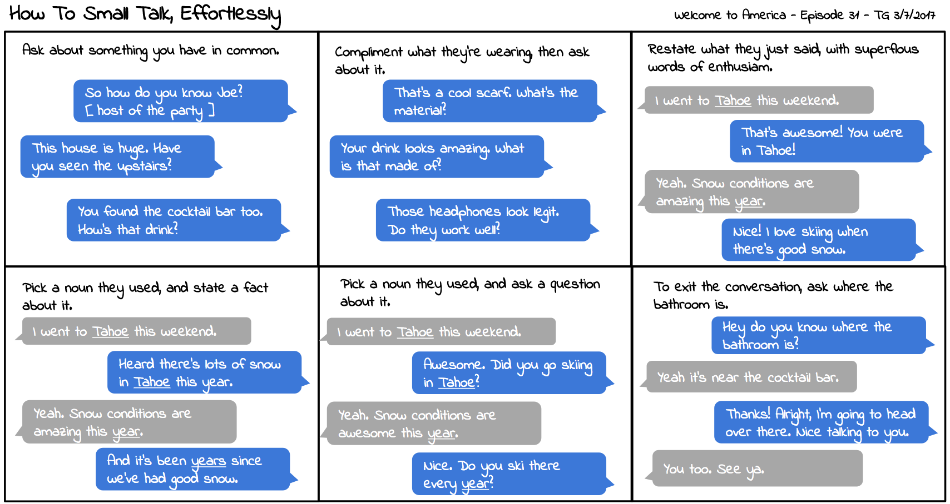

1. Fill in the right prepositions. Make the sentences true for you:
2. Tell me ___________ yourself.
3. The employer wants to focus ____ our education and work history.
4. Let them know what areas you have a lot of experience ____ .
5. I studied ________ … .
6. I graduated _______ ……………………………… ___________ …. .
7. I’ve been working … .
8. I have … years _____ experience ___ … .
9. Because ___ my time ____ ………………………., I have a lot _____ experience ___... .
10. Applicants should record themselves _________ a camera.
11. Tick the typical JI questions mentioned in the video:

